Oliver Collins-Cope

2102775@rutc.ac.uk

Learning aim A

Examine systems and services that form part of the Internet of Things

UNit 19 Internet Of Things

Assignment 1

Contents

Introduction 2

**What is the IoT?** 2

What do we use IoT for? 3

**IoT Systems** 3

Home Sector 3

Health sector 3

Industrial and transportation sector 4

Retail and commerce sector 4

**Home Sector** 4

**Smart Doorbell** 4

*Purpose* 5

*How does it work?* 5

**Smart Lighting** 5

*Purpose* 6

*How does it work?* 6

**Health Sector** 7

**Remote Patient Monitoring** 7

*Purpose* 7

*How does it work?* 7

**Pacemaker** 8

*Purpose* 9

*How does it work?* 9

**Principles underpin the IoT** 9

Home Sector: Smart Light 9

Home Sector: Smart Doorbell 10

Health Sector: Remote Patient Monitoring 10

Health Sector: Pacemaker 11

**Characteristics of IoT systems and services** 12

Comparison of Home Sector 12

Smart Lighting risks 12

Smart Doorbell risks 12

Smart Lighting legal considerations 12

Smart Doorbell legal considerations 12

Smart Lighting sustainability 12

Smart Doorbell sustainability 13

Smart Lighting low mobility 13

Smart Doorbell low mobility 13

Smart Lighting time controlled 13

Smart Doorbell time controlled 13

Evaluation 13

Comparison of Health Sector 14

Remote patient monitoring risks 14

Pacemaker risks 14

Remote patient monitoring ethical and privacy considerations 15

Pacemaker ethical and privacy considerations 15

Remote patient monitoring legal consideration 15

Pacemaker legal considerations 15

Remote patient monitoring sustainability 16

Pacemaker sustainability 16

Remote patient monitoring benefits 16

Pacemaker benefits 16

Evaluation 16

# Introduction

This report aims to examine the real-world impact of IoT systems, and the various components, applications, and challenges associated with these systems in the modern world. Furthermore, it will highlight specific scenarios where IoT systems play a crucial role in enhancing quality of life and, in some cases, even saving lives, particularly within the healthcare sector.

# **What is the IoT?**

While the IoT (Internet of Things) is a relatively new concept and idea, coming around only in the 21st century, there remains a lot to be said about this innovative technology. The IoT refers to a network of objects embedded with electronics, software, sensors, and connectivity which enables them to connect and exchange data. This encompasses a wide range of devices, including physical objects, vehicles, household appliances, and other items that meet the aforementioned criteria.

## What do we use IoT for?

The IoT (Internet of Things) is widely utilized across the globe, encompassing a diverse range of industries. There are several key sectors, including:

* Home Sector
* Health Sector
* Industrial and Transportation Sector
* Retail and Commerce Sector

The applications of IoT vary greatly based on the specific industry or environment for which it is designed and implemented. For instance, in the Home Sector, IoT may be used to control a remotely operated radiator, while in the Transportation Sector, the focus may be on advanced traffic management systems rather than smaller devices like a radiator or thermostat.

# **IoT Systems**

The Internet of Things systems have a significant impact across various industries, including the Home, Health, Industrial and Transportation, and Retail and Commerce sectors. The role of these systems varies depending on the specific situation, with each sector leveraging IoT systems to improve quality of life and other relevant aspects. The following provides examples of IoT systems utilized in different sectors.

## Home Sector

The rise of the Internet of Things has had a profound impact on our daily lives. With an increasing number of devices able to connect to the internet and be controlled remotely, we now have greater control over many aspects of our homes. From smart cameras and thermostats, to speakers, lights, and plugs, these IoT devices are making it easier to manage our homes and enhance our daily experiences. With the use of a mobile app, we can control these devices from anywhere, at any time, making our homes more comfortable, convenient, and efficient places to live.

## Health sector

In the health sector, the IoT has had a major impact. It has completely overhauled the way the patients are receiving care alongside aiding the medical professionals that are providing said care. Due to the increasing production and emphasis on IoT systems, there exists a not insignificant number of devices that help to monitor and manage health conditions, such as wearable fitness trackers, smart scales, and other medical devices. These systems collect data to be analysed and compared to previously available data that helps to identify any potential health hazards or issues the patient might run into. This promotes more personalised care that is catered towards an individual, increasing the quality of care they receive. Additionally, IoT systems have enabled patients to connect to medical professionals remotely for different procedures such as a consultation or follow up, such as seen with AskMyGP in the UK. Finally, this has allowed the healthcare system to be much more accessible for everyone.

## Industrial and transportation sector

The impact of IoT systems in the industrial and transportation sector is undeniable. IoT has transformed the way businesses and organizations operate, providing real-time data and insights on various systems. This has led to improved efficiency, reduced downtime, and increased productivity. IoT sensors, for instance, can monitor industrial machinery and vehicles, giving businesses valuable information on their performance and location. This optimizes processes and procedures, making operations more effective.

In transportation, IoT systems are used for tracking and monitoring vehicles, resulting in faster delivery times and increased road safety. Furthermore, integrating IoT can also help reduce fuel consumption and promote eco-friendliness in businesses.

## Retail and commerce sector

The retail and commerce sector has benefitted from the use of IoT systems in a variety of ways. However, there any many opportunities for improvement that can be found detailed below.

One example is the implementation of smart shelves, which keep track of inventory levels and let store managers know when stock is running low. Another is smart shopping carts that help customers keep track of their purchases and simplify the checkout process. IoT sensors can also be used in inventory management systems to monitor the movement of goods within a store. Electronic price tags, updated remotely with IoT, can eliminate the need for manual updates. Customer experience can be improved through the use of IoT sensors and cameras that gather data on customer behaviour. Predictive maintenance using IoT sensors can prevent equipment downtime. Contactless payment systems using IoT technology reduce the risk of infection and augmented reality displays provide customers with interactive product information and recommendations.

# **Home Sector**

## **Smart Doorbell**

A smart doorbell is a great example of an IoT system that is commonly used in the home sector. A famous example of the smart doorbell is the ring camera, which works through an application on the phone and an internet connection.

### *Purpose*

The purpose of the smart doorbell in the home sector varies depending on the person, however it follows the general idea of serving as a way for people to view their front door while not answering the door or not being home. Another purpose for this IoT system is to be used as a way to receive a parcel or speak to the delivery driver in order to request that a parcel is left inside or nearby, or any other instructions.

#### Evaluation

The smart doorbell plays an important role in the home sector and when it comes to being able to complete its purpose of allowing users to view their camera feed of their front door and be able to respond to people knocking, it completes this role effectively. It is essential in completing this and I evaluate it to have a high purpose

### *How does it work?*

The smart doorbell works similarly to most IoT systems. In this specific example of the Ring doorbell, it works by first being calibrated and connected to a network that is constantly operating nearby. This is most commonly done on a mobile device such as a phone or tablet, however some products may offer a desktop setup. Once the doorbell has been connected to a network, it is setup outside of a door and holds a sensor that works based on motion detection or button activation when someone would press a button on the doorbell to “ring” the doorbell. This then sends a notification through the internet onto a mobile device that also has an internet connection, and also has the specific software for the hardware, which in this situation is the doorbell. Once the notification has been received, the user can access the application and view the live camera feed, choosing whatever action they want, whether that be answering the door or talking to the person through the doorbell.

## **Smart Lighting**

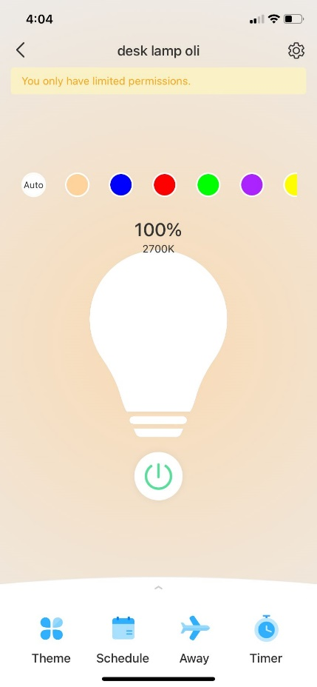Smart lighting is another great example of an IoT device that has come into the limelight recently. It provides people with a way to control lighting both inside and outside of the house, ensuring that money is not lost on electricity bills from the lighting. Additionally, these lights usually tend to be LEDs with multiple colour options, giving more life to peoples living rooms and many more.

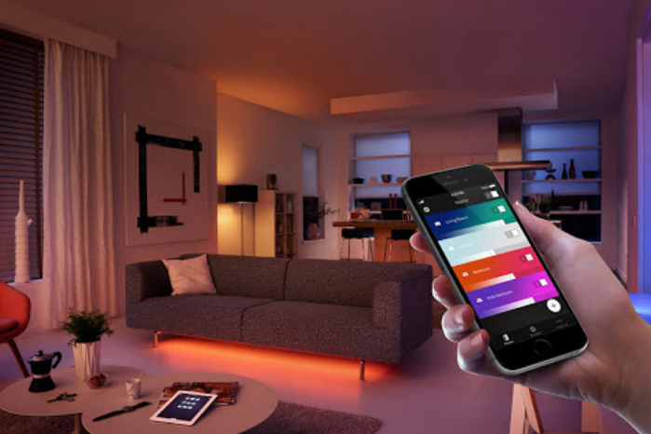

### *Purpose*

As mentioned above, the primary purpose of smart lighting is to provide people with a way to turn lights off and on remotely. This has a host of benefits that greatly improve quality of life, such as being able to control all the lights in the house from a mobile phone, and not having to worry about whether all lights are disabled once someone leaves the house as they can just check through their phone. They also tend to have an added benefit of offering multiple colour options and being LED lights.

#### Evaluation

The smart doorbell completes its role in the home sector effectively, providing many benefits to the user as it allows them to control their lighting through their phone, meaning that not only can they save on their bills, but they can also improve their quality of life by performing actions like turning their light off from the bed, etc. Because of this, I evaluate the smart lighting as highly effective.

### *How does it work?*

Smart lighting works similarly to the Smart Doorbell. Initially, the light is screwed into an empty light. From there, a user will have a specific application that they are required to download, the software, in order to connect to the light and calibrate it. Similarly, the light must be calibrated by being connected to the network so it has constant access to the internet. Once calibrated, the user is then able to send a signal through the internet containing the instructions for the light that they accessed through the application, such as turn on, turn off, change colour, and change brightness.

# **Health Sector**

## **Remote Patient Monitoring**

Remote patient monitoring is one of the most recent inventions from the health sector that allow clinicians and technicians to monitor patient’s health from remote locations such as their office. It works as a way for patients to remain out and about while also remaining monitored, giving them more freedom in their life but not sacrificing their safety, security and health.

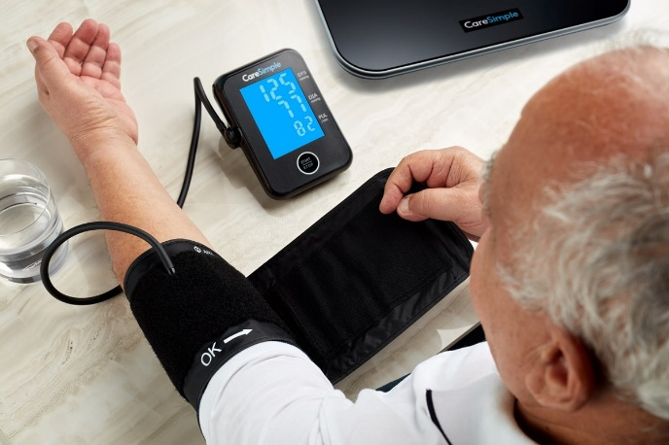 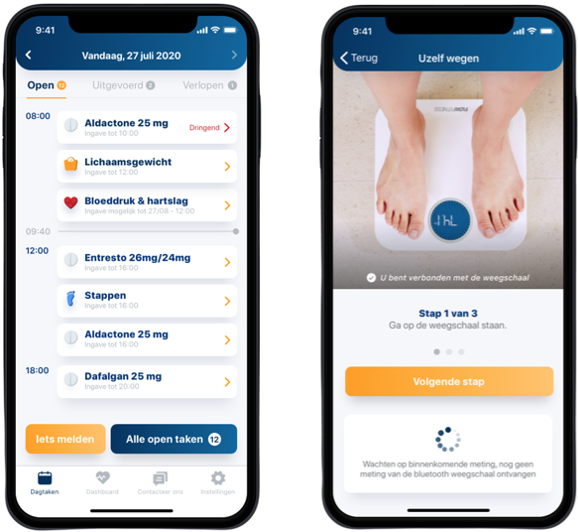

### *Purpose*

The purpose of remote patient monitoring is to communicate important information about patients to clinicians and technicians, and once this information has been communicated then the healthcare professionals are able to make adequate and important decisions while being well informed. Finally, this is a great way for patients to continue to live their life while not jeopardising their health and the quality of any reports they might have to make about it.

#### Evaluation

Remote patient monitoring enables patients to receive support and assistance through the technology provided, meaning that it saves the patients time and potentially saves their lives through the assistance they are receiving. It is due to the fact that it can play a life saving role in patients’ lives that I believe it should be evaluated highly against its supposed purpose.

### *How does it work?*

Remote patient monitoring works by connecting to a mobile device through a network like Bluetooth or 4G, and then transmits the necessary data to the hospitals and healthcare professionals. One device that tracks information like this is a weight scale, and another example is a blood pressure monitor. This is accomplished by connecting these to the network or mobile device, which sends the information to the hospital without any input from the patient.

## **Pacemaker**

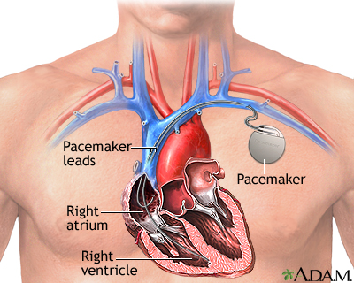 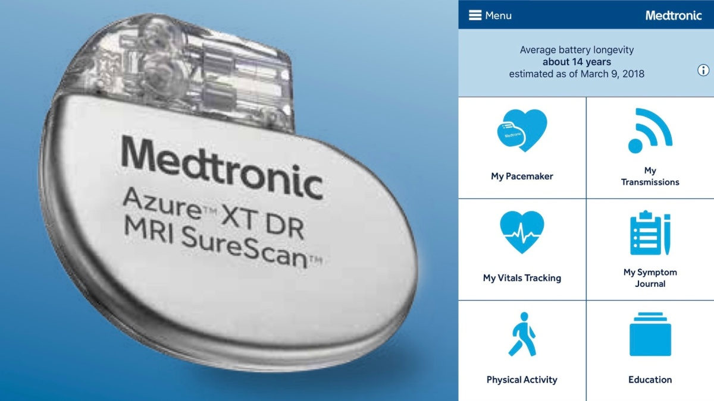

A pacemaker is a vital piece of IoT that works inside of patients to send electronic pulses to your heart to keep it beating at a regular and adequate speed in order to make sure that your heart is functioning properly, and there are no issues with your heartbeat. This is a device that can be crucial in improving people’s quality of life if people have issues with slow heartrate and for others, it can be lifesaving.

### *Purpose*

The purpose of a pacemaker is described as above. It works to keep the heart beating at a constant and regular pace to make sure that it is not too slow. This can prevent a number of issues, most notably, a slower heartbeat which can greatly impact someone’s ability to live a normal life. It causes issues such as chest pain, confusion, memory problems, and dizziness or light-headedness.

#### Evaluation

When considering the benefits and the risks of the pacemaker, it is clear that the benefits of being able to live a normal life without the risk of heart issues causing pain, and possibly death, everyday and being able to perform everyday functions, pacemakers are clearly worth it. Furthermore, I would also evaluate a pacemaker highly as I believe that the work it does in the healthcare sector is phenomenal and helps to save many lives.

### *How does it work?*

A pacemaker works by being installed just above someone’s heart under their collarbone, and senses, using wires, whether or not the heart is beating fast enough. If it is not, or it misses even a single beat, it sends an electrical pulse to the heart, causing it to beat. Recently, pacemakers have had options to connect to a network, giving information to doctors and healthcare professionals about the patient data and information regarding their heartbeat. This is calibrated before it is installed by the healthcare professional/hospital employee.

# **M1 Principles underpin the IoT**

## Home Sector: Smart Light

A smart light bulb and a smart doorbell are both excellent examples of IoT devices that embody the principles of IoT systems and services. They operate through similar principles, yet each device has its own unique features and functionalities.

A smart light bulb is a great example of an IoT device that showcases the principles of IoT systems and services. The smart light bulb connects to a mobile application and operates through the following principles:

Starting with the smart light bulb, it utilizes its connection to a mobile application to showcase IoT principles. This is similar to a smart doorbell which needs a connection to a mobile phone to view the camera feed.

By collecting and analysing data on the light levels in the room, it can respond to user preferences, turning on or off accordingly. This is also in line with the smart doorbell which can collect data on visitors at the door and send mobile notifications.

This device relies on existing internet and telecommunications infrastructure for user connectivity, enabling them to manipulate the lamp. Similarly, without internet access, the smart doorbell would not have access to the mobile device and not operate.

With real-time access, it can dynamically adjust to changes in the environment, adapting to darker or brighter conditions. Similarly to the light, real time data analysis also allows the smart doorbell to make decisions about the collected information, like whether to send a notification.

The smart light bulb accesses analogue data from the physical world, empowering users to automate light levels based on factors like ambient lighting or timing. The smart doorbell also has access to data like the audio and video, which it can transmit to the users applications for viewing.

With always-on connectivity, it can continuously monitor the light and leverage the spectrum of insight in real-time for accurate decision-making. Through always on connectivity, the smart doorbell is similar in that it can monitor, like with surveillance.

While both devices operate on the principles of IoT systems and services, they each have their distinct functionalities.

The smart light bulb emphasizes light level monitoring and automation, whereas the smart doorbell focuses on visitor identification and real-time notifications.

Nevertheless, both devices contribute to the interconnectedness and convenience offered by the Internet of Things, showcasing the potential for seamless integration of everyday objects into a digital ecosystem.

#### Evaluation

The smart light does not have as many complex factors that the principles consider, however the principles that the smart lighting does have an impact on are completed effectively and efficiently to ensure that all of the factors are met.

## Home Sector: Smart Doorbell

A smart doorbell is another example of an IoT device that demonstrates the principles of IoT systems and services. The smart doorbell operates through the following principles:

The smart doorbell will collect data on who is at the door and send a notification to mobile device. The smart light bulb, on the other hand, focuses on illuminating the room and enhancing the ambiance, by gathering data on light levels.

To further that, the smart doorbell needs access to the internet in order to be able to send the notification or live feed to the mobile device. Similar to the smart doorbell, the smart light bulb relies on internet connectivity to establish a connection with the mobile application, allowing remote access and viewing.

Using access to and analysis of the real time data the smart doorbell might be able to make decisions based on the results of this. While the smart doorbell analyses real-time data to make informed decisions, the smart light bulb utilises real-time data analysis to adjust its brightness and colour temperature.

It has access to audio and video data that it is then able to transmit to the mobile device for the user to view and access. While the smart doorbell has access to audio and video data for user viewing, the smart light allows users to interact with and personalize their lighting experience.

It must have always on connectivity as this allows the device to be constantly on and continuously monitor the camera feed that it can send to the user. Similarly, always on connectivity ensures that the light bulb remains responsive and can adapt to the users' preferences and environmental conditions

The spectrum of insight allows the smart doorbell to follow the five phases to analyse and model data for the user and store it in an archive. Contrary to the doorbell, the smart light bulb employs it to enhance the user's experience by providing various lighting modes, scheduling options, and energy efficiency features.

In summary, while the smart doorbell focuses on security and visitor monitoring, the smart light bulb caters to illuminating and enhancing the ambiance of the space. Both devices leverage connectivity, data analysis, and user interaction, albeit in different ways, to provide convenience and personalized experiences.

#### Evaluation

Similarly, the smart doorbell system does not have many factors that that impact the principles.

However, the principles that are involved require constant upkeep, such as being connected to the internet or providing a constant data flow of the camera feed, and therefore I believe that compared to the smart light, the smart doorbell has more to keep track of and requires more maintenance, meaning the principles have more of an impact compared to previously mentioned smart light.

## Health Sector: Remote Patient Monitoring

Remote Patient Monitoring (RPM) is a healthcare application of IoT technology that demonstrates the principles of IoT systems and services. RPM operates through the following principles:

The RPM collects and analyses patient data and uses this to perform functions such as sending an alert to the healthcare provider if the data is outside of normal ranges.

RPM relies on the existing internet and telecommunications infrastructure to function properly, otherwise the RPM would not be able to send or transmit any data, as well as not being able to monitor accurately.

RPM has access to real time data that it must transfer to medical professionals, and without this access to the data it would be unable to send anything regarding the patient to the medical professional. Furthermore, it must analyse the data to ensure that it only transmits important information or alarming anomalies.

RPM has access to analogue data from the physical world, perhaps such as time of day and light levels. This could be used to monitor sleep schedules, etc.

RPM has always on connectivity as without it there may be times when the patient is unmonitored and something dangerous could occur, meaning it is vital to ensure it is active.

RPM uses the five-phase spectrum of insight to continuously monitor the patients data and ensure that nothing out of the ordinary happens to them.

#### Evaluation

RPM is more complex in its nature, given that it is used to aid in treating patients and ensuring that they remain healthy.

This means that the principles behind remote patient monitoring have more detail and complexity involved, which helps to ensure that patients are healthy and nothing happens to them.

Due to the added complexity of the health sector, combined with the life saving nature of RPM, I believe that there are more benefits compared to the aforementioned IoT technologies and is therefore evaluated higher compared to those.

## Health Sector: Pacemaker

A pacemaker is a medical device that demonstrates the principles of IoT systems and services. The pacemaker operates through the following principles:

The pacemaker must collect and analyse data on the patient's heart rate and rhythm to make sure that all their needs are being met, such as sending an electric shock when the heartbeat is not functioning properly.

It relies on the internet and infrastructure to transmit any data or information it collects to the medical professionals about the patients.

The pacemaker has access to real-time data to ensure that medical professionals are able to monitor and react to any changes in the patient’s heartbeat effectively and efficiently.

It uses analogue data to track real world variables like time and light levels, to ensure that all the data it is monitoring is accurate, such as when the patient is exercising or going through heartbeat increasing activity.

The pacemaker must have always on connectivity otherwise the patient’s life could be at risk due to not sending the information to the healthcare professionals if something occurs and not providing the correct shock to ensure the heart beats properly.

The spectrum of insight allows the patient data to be monitored accurately and analysed, before being archived for future use and to compare against the patient’s current health.

#### Evaluation

Similarly to the RPM technology, the pacemaker is much more complex, which inherently adds more detail and information regarding it.

In addition to the extra information, the pacemaker also provides many more benefits for the users as it enables them to continue living a relatively normal life and reduces many of the health complications that they might have run into in the past.

Finally, when considering the principles of the pacemaker and the impact they have on the data and information, it is clear that they play an important role in ensuring that it proceeds normally and are therefore crucial to the pacemaker.

# **Characteristics of IoT systems and services**

## Comparison of Home Sector

### Smart Lighting risks

There are minimal risks associated with a smart lighting system as the consequences of the device being breached are minimal.

There are no risks such as payments being compromised, or the data being extracted.

### Smart Doorbell risks

This is completely different to the smart doorbell which monitors camera feed and if the data is compromised then there is a chance of someone being able to monitor the camera feed and viewing the contents of it.

This could provide them information like the camera’s address/location.

### Smart Lighting legal considerations

Within a smart lighting system there are not many legal considerations that have to be considered when talking about the incidents that might occur.

The only data that might be collected without consent could be a login details for the application, and other than this there is nothing that should be of issue.

### Smart Doorbell legal considerations

Contrary to smart lighting, smart doorbells have many legal considerations that must be observed due to the impact of them.

For example, the same issue of data collection if much larger with a smart doorbell, due to the ability to record footage and information, and this could be illegally or unethically monitored by an outside individual.

This could eventually lead to information/date of the footage being stolen or viewed by others without consent, and this is a legal consideration that has much significance.

### Smart Lighting sustainability

The smart lighting does have sustainability considerations as it is something that uses power continuously and therefore the sustainability of running a light is important to consider.

However, the smart lighting often provides options to control the light from outside of the home, or set up timed schedules, which provides many options to ensure that the light is very sustainable and therefore is great for this.

### Smart Doorbell sustainability

The smart doorbell is similar to this as it provides the option to control the device remotely. This means that the smart doorbell is able to be turned on and off when away from home and therefore helps to remain sustainable.

Furthermore, smart doorbells are often motion activated and only turn on when someone or something triggers the motion detection software, saving power and making it more sustainable by only being used when needed.

### Smart Lighting low mobility

A smart lighting system has little to no mobility, only moving around if the light bulb is to occupy another spot or when being set up.

Additionally, the only device the smart lighting has a connection to, the application that controls it, will only move around when the user moves with the application, however due to the fact that it is an application and not the physical IoT item, the smart lighting does not move.

### Smart Doorbell low mobility

Similarly to a smart lighting system, a smart doorbell system has no mobility as it is installed into one location and will remain that way until it is either moved for a specific reason or uninstalled.

Also similarly, the application is the only thing that will move around connected to the smart doorbell, but this does not count as the actual IoT system and therefore it does not move.

### Smart Lighting time controlled

A smart lighting system does often have the ability to be time controlled and therefore falls under this category.

The smart lighting application associated with the IoT system means that it has the option to set up predetermined time system that changes the lights based on what time it is to any setting that was established.

### Smart Doorbell time controlled

In comparison to the smart lighting system, the smart doorbell has no obvious time control settings.

There are no settings or functions that could be created either for the smart doorbell, as it is a system that relies on being constantly activated in order to do its job properly, i.e., monitoring motion.

### Evaluation

I believe that the most important factor of the home sector when discussing the characteristics and the impact they have on the development, design, and production of the products, has to be the sustainability of the products, alongside the quality of life improvements that they offer.

This is because of the fact that the most common usage of IoT technology in the home sector is based around convenience and improving the home lifestyle, which means that the technology must be sustainable and last long enough to make the purchase worth it, otherwise the entire point of the technology is blown over.

Eventually, this would lead to more bother and work than convenience, defeating the purpose of IoT systems in the home.

On the other hand, I believe that the low mobility characteristic of certain IoT systems is the least important factor as it does not play as much of a role in IoT systems.

Most technology will not be developed around the idea of it remaining in one place, and will simply be an innate characteristic depending on the product, therefore meaning that it is not necessarily an essential characteristic, leading me to evaluate it as the lowest compared to the above mentioned characteristics.

Finally, it is important to also consider the context of the situation rather than blindly assuming whether one characteristic is more important than the others.

For example, with my chosen technologies I have only mentioned the characteristics that apply, however if I was to use a different technology then I would have to re-evaluate the characteristics that apply to that technology and which is the most important compared to the least important.

## Comparison of Health Sector

### Remote patient monitoring risks

There are some risks associated with remote patient monitoring as this field involves highly sensitive data and information that includes your medical history, and therefore there is a risk of unauthorised access of this data.

For example, some of the sensitive data could include things like: heart rate, body mass index, weight, and any other health conditions like illnesses or mental health disorders.

This puts the patient’s medical history and monitored data at risk of exposure.

### Pacemaker risks

Similarly to remote patient monitoring, there are risks associated with pacemakers.

This is contrary to the remote patient monitoring which is not as life threatening, however as pacemakers start to become IoT enabled, there is a risk of them being hacked and controlled, leading to the hacker potentially putting the patient in life threatening complications by modifying the pacemaker.

Finally, they could also access any data and information that is being transmitted by the pacemaker, leading to patient medical information being stolen, which is similar to the remote patient monitoring.

### Remote patient monitoring ethical and privacy considerations

There are many remote patient monitoring(RPM) ethical and privacy considerations that have to be considered when using RPM.

One of these examples is the ethical issue of the wealth gap. Poorer and lower income families might not be able to afford the right medical treatment that is needed, such as RPM, and this promotes the age old issue that comes with healthcare and whether or not we should be hiding life saving treatments behind a paywall.

This is a big ethical issue and is one that should be debated and discussed heavily before we decide to proceed with expensive treatments options.

### Pacemaker ethical and privacy considerations

Similarly as mentioned above in the risks of pacemakers, there is a big risk of the pacemakers being hacked.

If the pacemakers are hacked then this could lead to the data that the pacemakers collect about the patients being breached and accessed by unauthorised users, which is a huge privacy consideration.

Additionally, there is also the question of how IoT pacemakers will impact the role of other healthcare professionals.

For example, while there is little to no chance of the pacemakers replacing high level jobs within healthcare, there is a possibility that the lower skilled healthcare jobs could be replaced and lost.

### Remote patient monitoring legal consideration

One legal consideration of remote patient monitoring is the fact that the patient data collected through RPM must be collected through legal and proper means.

This means that when establishing RPM, all the correct legal routes must be taken in order to ensure that the patients consent is documented and can be referred to in the future if an issues should arise with the RPM.

Additionally, there are also the legal considerations for any liabilities that occur related to RPM technology. Due to this, it is essential that the technologies are developed in a way that minuses risks and injuries to the patients and ensures the safe use of them.

### Pacemaker legal considerations

The pacemaker has similar legal considerations as RPM technology. This means that pacemakers have to ensure that there are a number of factors that continue to operate smoothly for there to be minimal legal issues.

For example, just like above, there must be patient consent, and compliance with any regulations that apply to medical devices, also similarly to RPM technology.

Finally, there is also liability for the pacemaker technology if it fails or something goes wrong, just like the remote patient monitoring technology. This means that these factors must be considered and included when deciding to move forward with IoT pacemakers.

### Remote patient monitoring sustainability

RPM technology is similar to most technology in that it is not self-sustainable and requires a constant source of power.

This means that in order for RPM to work efficiently it has to have access to power and be able to connect to the internet in order to transmit any data.

To conclude, remote patient monitoring is not very sustainable as it cannot function without an external power source.

### Pacemaker sustainability

Pacemakers are slightly different from remote patient monitoring in that they operate independently for years before they need to be changed or have their batteries replaced.

This is different from the aforementioned remote patient monitoring, as pacemakers have batteries implanted within them that last for years before they need to be replaced or modified.

Additionally, pacemakers are designed to consume as little power as possible to make these batteries last as long as possible, which is different to the RPM which needs a constant power source.

### Remote patient monitoring benefits

RPM offers a number of patient and general benefits, and this ranges from things as small as reducing the number of greenhouse gas emissions because patients do not need to travel to the hospital as often, to contributing to productivity gains by optimising how patients are cared for and looked after.

Additionally, RPM can help prevent the spread of disease by allowing medical professionals to monitor patients remotely and determine disease through this.

Finally, RPM also improves the quality of life for patients through their day to day life, reducing the need for hospital visits for check-ups and ensuring that any issues that arise are swiftly identified and dealt with.

### Pacemaker benefits

Pacemakers also have many benefits that enhance the patients lives a number of means.

For example, pacemakers are extremely energy efficient as they only need to be replaced once every several years and are designed to operate independently like this for extensive periods of time.

Additionally, pacemakers can contribute to productivity gains by improving the health and wellbeing of patient, enabling them to stay active and healthy, including maintaining a normal lifestyle that might otherwise be limited because of their health conditions.

### Evaluation

I believe that the most important characteristics of the health sector in regards to the technology I have chosen are the benefits and the risks.

This is due to the fact that the benefits provided by the healthcare sector IoT systems are unmatched compared to any other characteristics. Not only does it help to save lives, which in turn allows people to experience *any* of the characteristics of IoT systems, but it helps to improve the users health and quality of life, such as enabling them to perform exercise or sport activities.

Additionally, I believe that risk is also an important factor that must be considered as the risks of healthcare sector IoT systems usually have the most disastrous consequences.

An example of this would be an IoT pacemaker which, if something would go wrong, could lead to patient data and information being stolen, alongside putting their life at risk through the pacemaker performing/behaving irregularly and hurting the user/patient.

On the other hand, I believe that the least important factors for consideration, of those that apply to my chosen technology, might be the ethical and privacy considerations.

Although this is still a huge characteristic of the technology I have chosen, I believe that compared to the capability to save patients’ lives and improve their ability to live a day to day lifestyle, the cost for this technology might not always be cheap and widely accessible unfortunately.

This leads to the fact that ethical and privacy concerns are not above the patients lives and should not be put first in the face of medical lifesaving technology.

Finally, just like the home sector, the context of the scenario, and in this case the context of the technology, always takes more priority compared to a predetermined opinion.

There are likely technologies out there where the ethics and privacy involved will take much higher priority compared to the benefits, and therefore the context of the situation should always be taken into consideration when discussing what characteristics have the highest impact on the IoT technology of health systems.